APPENDIX L: INFORMATION

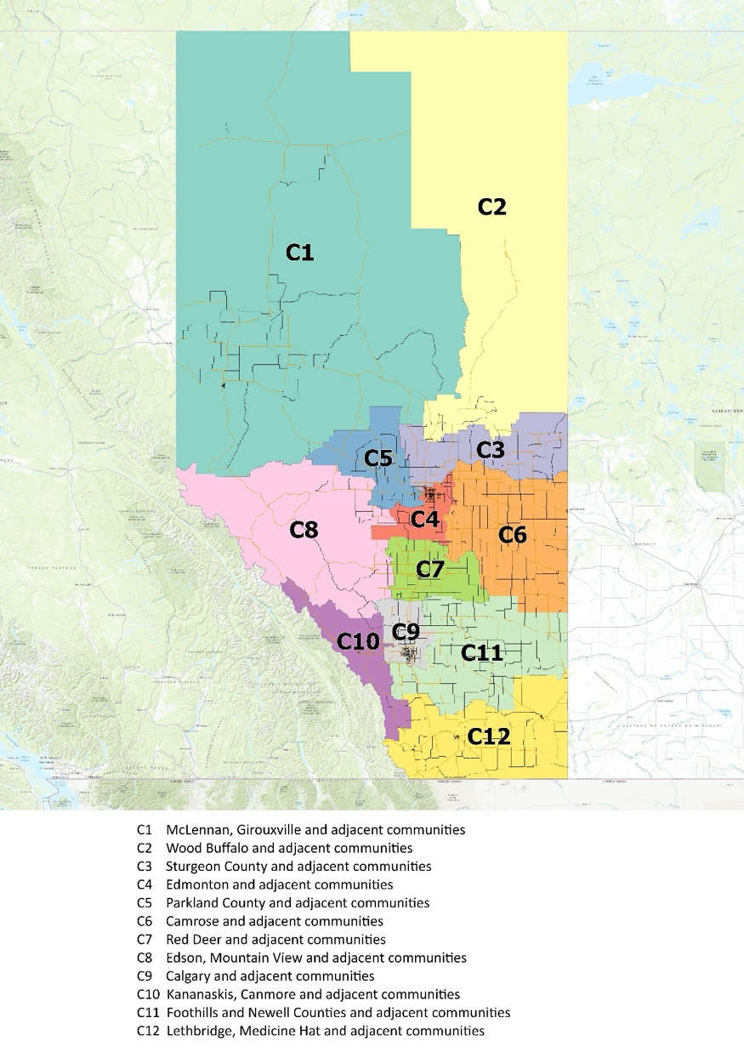
Appendix L-1 – Collection Catchment Areas

Appendix L-2 - Estimated Projected Collected Tonnes
*NOTE: The information in this Appendix L is based on available data at the time of the preparation of the RFP. Circular Materials holds no responsibility or liability for information that is different from the information presented in this Appendix L
Estimated Projected Collected Tonnes
as of October 1, 2026
Catchment Number | Registered Community | Form of Collection Service | Single Stream (tonnes) | Dual Stream (tonnes)
C1 | Berwyn, Village of | Depot Only | 29
C1 | Big Lakes County | Depot Only | 215
C1 | Clear Hills County | Depot Only | 116
C1 | Fairview, Town of | Both | 176
C1 | Falher, Town of | Both | 51
C1 | Girouxville, Village of | Depot Only | 15
C1 | Grande Prairie No. 1, County of | Both | 915
C1 | Grande Prairie, City of | Both | 2,873
C1 | Greenview No. 16, Municipal District of | Both | 518
C1 | High Level, Town of | Depot Only | 141
C1 | High Prairie, Town of | Depot Only | 112
C1 | Hines Creek, Village of | Both | 21
C1 | Lesser Slave River, Municipal District | Depot Only | 447
C1 | McLennan, Town of | Curbside Only | 34
C1 | Nampa, Village of | Depot Only | 18
C1 | Northern Lights County, Municipal District of | Depot Only | 166
C1 | Northern Sunrise County | Depot Only | 93
C1 | Opportunity No.17, Municipal District of | Depot Only | 115
C1 | Peace No 135, Municipal District of | Depot Only | 72
C1 | Peace River, Town of | Both | 301
C1 | Saddle Hills County | Depot Only | 119
C1 | Sexsmith, Town of | Curbside Only | 109
C1 | Slave Lake, Town of | Both | 298
C1 | Spirit River, Town of | Depot Only | 40
Catchment subtotal |  |  | 6,994
C2 | Athabasca County, Municiapal District of | Depot Only |  | 749
C2 | Athabasca, Town of | Both |  | 178
C2 | Bondiss, Summer Village of | Depot Only | 7
C2 | Boyle, Village of | Both |  | 41
C2 | Fort McKay First Nation | Depot Only | 23
C2 | Heart Lake, First Nation of | Depot Only | 6
C2 | Island Lake South, Summer Village | Depot Only | 5
C2 | Island Lake, Summer Village | Depot Only | 9
C2 | Lac La Biche County | Both | 450
C2 | Mewatha Beach, Summer Village | Depot Only | 6
C2 | South Baptiste, Summer Village | Depot Only | 4
C2 | Sunset Beach, Summer Village | Depot Only | 3
C2 | West Baptiste, Summer Village | Depot Only | 3
C2 | Whispering Hills, Summer Village | Depot Only | 6
C2 | Wood Buffalo, Regional Municipality of | Both | 4,228
Catchment subtotal |  |  | 4,750 | 968
C3 | Bon Accord, Town of | Both | 61
C3 | Bonnyville Beach, Summer Village | Depot Only | 3
C3 | Bonnyville No. 87, Municipal District of | Depot Only | 709
C3 | Bonnyville, Town of | Depot Only | 329
C3 | Clyde, Village of | Curbside Only | 24
C3 | Cold Lake, City of | Both |  | 703
C3 | Elk Point, Town of | Depot Only | 63
C3 | Legal, Town of | Both | 52
C3 | Morinville, Town of | Both | 417
C3 | Redwater, Town of | Both | 111
C3 | Smoky Lake County, Municipal District of | Depot Only | 161
C3 | Smoky Lake, Town of | Depot Only | 48
C3 | St Paul County No.19, Municipal District of | Depot Only | 266
C3 | St Paul, Town of | Depot Only | 180
C3 | Sturgeon County | Depot Only | 752
C3 | Thorhild County | Both | 144
C3 | Vilna, Village of | Depot Only | 12
C3 | Westlock County of | Depot Only | 383
C3 | Westlock, Town of | Both | 230
Catchment subtotal |  |  | 3,945 | 703
C4 | Beaumont, City of | Both | 828
C4 | Calmar, Town of | Both | 100
C4 | Devon, Town of | Both | 255
C4 | Edmonton, City of | Both | 46,211
C4 | Fort Saskatchewan, City of | Both | 2,546
C4 | Leduc, City of | Both | 1,339
C4 | Silver Beach, Summer Village | Depot Only | 3
C4 | St. Albert, City of | Both | 2,921
C4 | Strathcona County, Specialized Municipality | Both | 4,015
C4 | Sunrise Beach, Summer Village | Depot Only | 10
C4 | Wetaskiwin No. 10, County of | Depot Only | 555
C4 | Wetaskiwin, City of | Depot Only | 544
Catchment subtotal |  |  | 59,327 | 0
C5 | Alberta Beach, Village of | Curbside Only | 80
C5 | Birch Cove, Summer Village of | Depot Only | 7
C5 | Castle Island, Summer Village of | Depot Only | 2
C5 | Lac Ste. Anne County | Both | 661
C5 | Mayerthorpe, Town of | Curbside Only | 80
C5 | Nakamun Park, Summer Village | Depot Only | 4
C5 | Onoway, Town of | Curbside Only | 40
C5 | Parkland County | Both | 1,480
C5 | Paul First Nation (Wabamun 133) | Depot Only | 21
C5 | Silver Sands, Summer Village of | Curbside Only | 26
C5 | South View, Summer Village | Curbside Only | 3
C5 | Spruce Grove, City of | Both | 1,510
C5 | Stony Plain, Town of | Both | 765
C5 | West Cove, Summer Village | Depot Only | 12
Catchment subtotal |  |  | 4,691 | 0
C6 | Alliance, Village of | Depot Only | 11
C6 | Beaver, County of | Depot Only | 234
C6 | Bigstone Cree Nation | Depot Only | 34
C6 | Camrose, City of | Depot Only | 1,003
C6 | Castor, Town of | Depot Only | 47
C6 | Chauvin, Village of | Curbside Only | 17
C6 | Coronation, Town of | Both | 46
C6 | Daysland, Town of | Depot Only | 37
C6 | Edgerton, Village of | Depot Only | 21
C6 | Flagstaff County, Municipal District of | Depot Only | 180
C6 | Forestburg, Village of | Depot Only | 40
C6 | Halkirk, Village of | Depot Only | 5
C6 | Hardisty, Town of | Depot Only | 43
C6 | Heisler, Village of | Depot Only | 9
C6 | Holden, Village of | Depot Only | 18
C6 | Killam, Town of | Depot Only | 43
C6 | Kitscoty, Village of | Depot Only | 36
C6 | Lougheed, Village of | Depot Only | 16
C6 | Mannville, Village of | Both | 52
C6 | Minburn County, Municipal District of | Depot Only | 121
C6 | Mundare, Town of | Curbside Only | 41
C6 | Myrnam, Village of | Depot Only | 13
C6 | Paintearth County No 18 | Depot Only | 70
C6 | Provost No.52, Municipal District of | Depot Only | 90
C6 | Provost, Town of | Depot Only | 81
C6 | Rosalind, Village of | Depot Only | 10
C6 | Ryley, Village of | Depot Only | 24
C6 | Sedgewick, Town of | Depot Only | 39
C6 | Tofield, Town of | Depot Only | 97
C6 | Vegreville, Town of | Both | 593
C6 | Vermilion, Town of | Curbside Only | 132
C6 | Viking, Town of | Depot Only | 46
C6 | Wainwright No. 61, Municipal District of | Depot Only | 197
C6 | Wainwright, Town of | Both | 261
Catchment subtotal |  |  | 3,707 | 0
C7 | Alix, Village of | Curbside Only | 44
C7 | Bashaw, Town of | Curbside Only | 46
C7 | Bentley, Town of | Depot Only | 48
C7 | Birchcliff, Summer Village of | Curbside Only | 10
C7 | Blackfalds, Town of | Both | 441
C7 | Bowden, Town of | Curbside Only | 57
C7 | Clive, Village of | Curbside Only | 35
C7 | Delburne, Village of | Both | 43
C7 | Eckville, Town of | Both | 53
C7 | Elnora, Village of | Curbside Only | 16
C7 | Half Moon Bay, Summer Village of | Curbside Only | 7
C7 | Innisfail, Town of | Both | 299
C7 | Jarvis Bay, Summer Village of | Curbside Only | 16
C7 | Lacombe, City of | Depot Only | 542
C7 | Lacombe, County of | Depot Only | 430
C7 | Norglenwood, Summer Village of | Curbside Only | 22
C7 | Penhold, Town of | Curbside Only | 840
C7 | Ponoka County | Depot Only | 777
C7 | Ponoka, Town of | Both | 358
C7 | Red Deer County | Depot Only | 1,152
C7 | Red Deer, City of | Both | 4,614
C7 | Stettler No.6, County of | Depot Only | 247
C7 | Stettler, Town of | Both | 502
C7 | Sunbreaker Cove, Summer Village of | Curbside Only | 26
C7 | Sylvan Lake, Town of | Both | 810
Catchment subtotal |  |  | 11,435 | 0
C8 | Brazeau County | Depot Only | 305
C8 | Clearwater County, Municipal District of | Depot Only | 600
C8 | Edson, Town of | Depot Only | 760
C8 | Hinton, Town of | Depot Only | 429
C8 | Itaska Beach, Summer Village | Depot Only | 0
C8 | Jasper, Specialized Municipality of | Depot Only | 116
C8 | O'Chiese 203, First Nation | Depot Only | 24
C8 | Sundance Beach, Summer Village | Depot Only | 3
C8 | Yellowhead County | Depot Only | 445
Catchment subtotal |  |  | 2,682 | 0
C9 | Airdrie, City of | Both | 3,956
C9 | Beiseker, Village of | Both | 35
C9 | Calgary, City of | Both | 57,099
C9 | Carstairs, Town of | Curbside Only | 125
C9 | Chestermere, City of | Both | 1,473
C9 | Crossfield, Town of | Both | 122
C9 | Didsbury, Town of | Curbside Only | 230
C9 | Irricana, Town of | Both | 54
C9 | Mountain View County, Municipal District of | Depot Only | 537
C9 | Olds, Town of | Curbside Only | 397
C9 | Rocky View County | Both | 1,575
C9 | Sundre, Town of | Both | 127
Catchment subtotal |  |  | 65,730 | 0
C10 | Banff, Town of | Curbside Only |  | 405
C10 | Bighorn, Municipal District of (Bighorn No. 8, MD) | Depot Only | 94
C10 | Canmore, Town of | Both |  | 1,054
C10 | Cochrane, Town of | Both | 2,041
C10 | Improvement District No. 9 (Lake Louise) | Depot Only | 72
C10 | Kananaskis Improvement District | Depot Only | 10
C10 | Rocky Mountain House, Town of | Both | 466
C10 | Stoney Tribal Administration | Depot Only | 96
C10 | Waiparous, Summer Village of | Depot Only | 8
Catchment subtotal |  |  | 2,787 | 1,459
C11 | Acadia, Municipal District of | Depot Only | 17
C11 | Acme, Village of | Depot Only | 35
C11 | Arrowwood, Village of | Depot Only | 9
C11 | Bassano, Town of | Depot Only | 58
C11 | Brooks, City of | Depot Only | 636
C11 | Carbon, Village of | Depot Only | 47
C11 | Carmangay, Village of | Depot Only | 14
C11 | Champion, Village of | Depot Only | 18
C11 | Claresholm, Town of | Both | 203
C11 | Consort, Village of | Depot Only | 29
C11 | Delia, Village of | Depot Only | 25
C11 | Diamond Valley, Town of | Curbside Only | 240
C11 | Drumheller, Town of | Depot Only | 343
C11 | Duchess, Village of | Depot Only | 41
C11 | Empress, Village of | Depot Only | 7
C11 | Foothills County | Both | 1,061
C11 | Hanna, Town of | Depot Only | 117
C11 | High River, Town of | Depot Only | 618
C11 | Hussar, Village of | Depot Only | 11
C11 | Kneehill County | Depot Only | 186
C11 | Linden, Village of | Depot Only | 33
C11 | Lomond, Village of | Depot Only | 9
C11 | Milo, Village of | Depot Only | 5
C11 | Morrin, Village of | Depot Only | 25
C11 | Munson, Village of | Depot Only | 9
C11 | Nanton, Town of | Curbside Only | 112
C11 | Newell County, Municipal District of | Depot Only | 1,100
C11 | Okotoks, Town of | Both | 1,244
C11 | Oyen, Town of | Depot Only | 38
C11 | Rockyford, Village of | Depot Only | 43
C11 | Rosemary, Village of | Depot Only | 14
C11 | Standard, Village of | Depot Only | 40
C11 | Starland County, Municipal District of | Depot Only | 74
C11 | Stavely, Town of | Depot Only | 31
C11 | Strathmore, Town of | Depot Only | 654
C11 | Three Hills, Town of | Both | 154
C11 | Trochu, Town of | Both | 50
C11 | Veteran, Village of | Depot Only | 11
C11 | Vulcan County | Depot Only | 129
C11 | Vulcan, Town of* | Depot Only | 87
C11 | Wheatland County | Depot Only | 403
C11 | Youngstown, Village of | Depot Only | 8
Catchment subtotal |  |  | 7,988 | 0
C12 | Bow Island, Town of | Both | 73
C12 | Cardston County, Municipal District of | Depot Only | 155
C12 | Cardston, Town of | Depot Only | 138
C12 | Coaldale, Town of | Curbside Only | 340
C12 | Coalhurst, Town of | Depot Only | 113
C12 | Crowsnest Pass, Municipal District of | Depot Only | 357
C12 | Foremost, Village of | Depot Only | 23
C12 | Forty Mile County No. 8, Municipal County of | Depot Only | 92
C12 | Lethbridge, City of | Both | 4,300
C12 | Lethbridge, County of | Depot Only | 321
C12 | Magrath, Town of | Depot Only | 88
C12 | Medicine Hat, City of | Both | 2,895
C12 | Milk River, Town of | Depot Only | 47
C12 | Nobleford, Town of | Depot Only | 49
C12 | Picture Butte, Town of | Depot Only | 74
C12 | Pincher Creek No.9, Municipal District of | Depot Only | 193
C12 | Pincher Creek, Town of | Depot Only | 184
C12 | Raymond, Town of | Depot Only | 153
C12 | Redcliff, Town of | Depot Only | 234
C12 | Taber, Town of | Both | 358
C12 | Vauxhall, Town of | Depot Only | 53
C12 | Warner No. 5, County of | Depot Only | 94
C12 | Warner, Village of | Depot Only | 22
C12 | Willow Creek, Municipal District of | Depot Only | 276
Catchment subtotal |  |  | 10,632 | 0

Appendix L-3 – Composition of Collected Material in Alberta
*NOTE: The information in this Appendix L is based on available data at the time of the preparation of the RFP. Circular Materials holds no responsibility or liability for information that is different from the information presented in this Appendix L
A | B
2026
estimated proportion of Collected Material
OCC | 29.0%
Mixed Paper | 30.4%
PET | 3.4%
HDPE | 1.8%
#3-7 Mixed Rigid Plastic | 3.7%
Polycoat | 0.2%
Flexible Plastic Packaging | 3.3%
Aluminum | 0.2%
Steel cans | 1.8%
Glass | 4.5%
Scrap Metal | 0.9%
Beverage Containers | 0.7%
Contamination/Unrecoverable | 20.0%

